Oscar Academy



Under the Supervision of Ministry of Education and Higher Education

عطاء متزايد ...وثقة تتجدد

2016-2017

Second Semester April Monthly Exam Revision Paper

|  |
| --- |
| **Subject: English Grade 1** |
| **Name: _______________________________** |

**Q1 What day is it? Write your answer.**

1. What is the day before Tuesday? ____________________
2. What is the day after Thursday? ____________________
3. What is the day after Monday? ____________________
4. What is the first day of school? ___________________

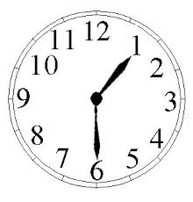**Q2 What time is it?** Write or draw the correct time.

1.

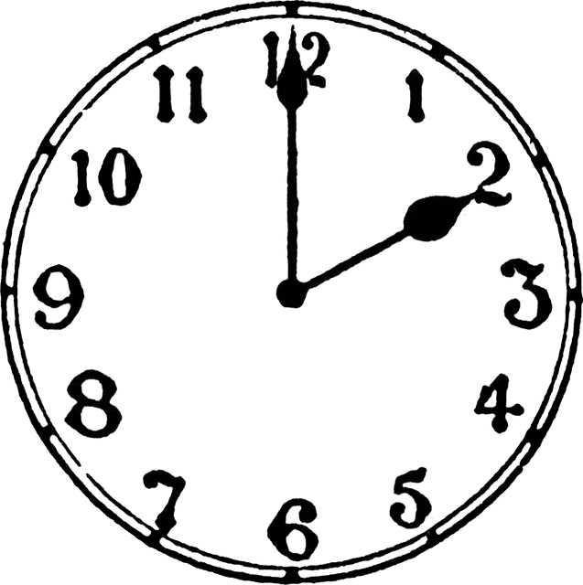

2.

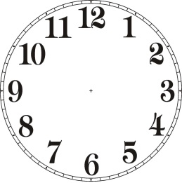

1. It is twelve o’clock.



1. It is half past three.



1. It is six o’clock.

**Q3 What do you call this shop? Writer your answer on the blank.**

Pet Shop Toy Shop Sweet Shop

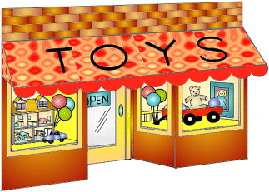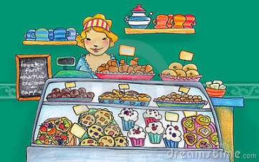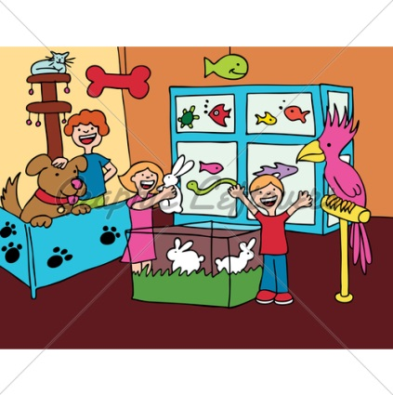

**Q4 Write the correct pronoun.**

He She It They

1. Ahmed is swimming. ______________ is swimming.
2. The cat is eating. _______________ is eating.
3. Jana is happy. _______________ is happy.
4. The children are playing. _______________ are playing.

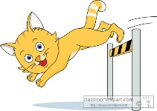**Q5 What are you doing? Look and write a sentence according to the picture.**

1. What is it doing?

It is jumping over the hurdle.

1. What is he doing?

________________________________________

1. What is she doing?

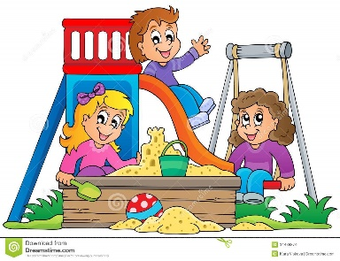________________________________________

1. What are they doing?

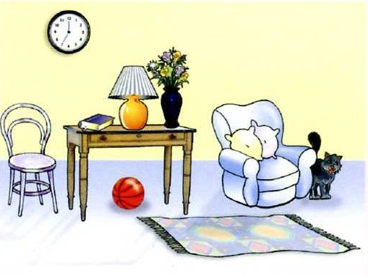Q6 Where is it? Write the correct preposition to answer the question.

1. The cat is __________ the chair.
2. The ball is ______________ the table.
3. The carpet is _______________ the table.
4. The clock is ________________ the table.
5. The lamp is ________________ the book and flowers.
6. The pillows are _______________ the sofa.
7. The flowers are _______________ the vase.___

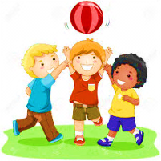Q7 **Complete the sentences with have or has.**

1. They ____________ got a ball.

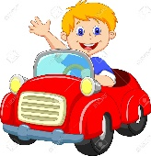

1. He _____________got a toy car.



1. 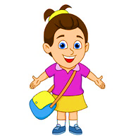She _____________ got a flower.
2. I _____________ got a bag.



1. It _____________ got sunglasses.

**Q8 Phonics**

1. 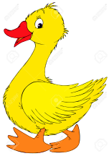**Spell the correct word of the given pictures.**

1. ________________



1. ________________

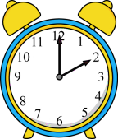

1. ________________

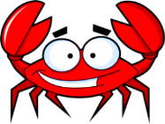

1. ________________



1. ________________

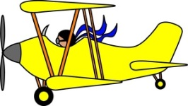

1. ________________



1. ________________

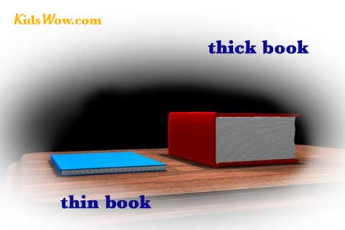

1. ________________

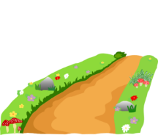

1. ________________

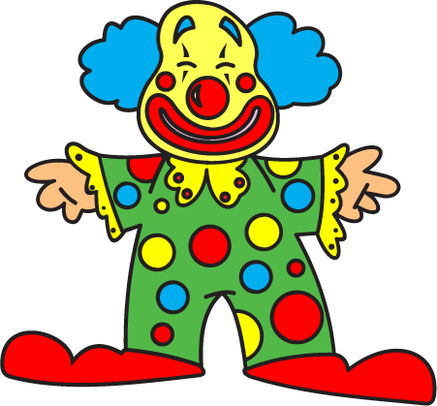

1. ________________



1. ________________

**Q9 Sentence Writing**

**Look at the picture. Write four sentences about it using “*There is*” or “*There are*” and *preposition*.**

